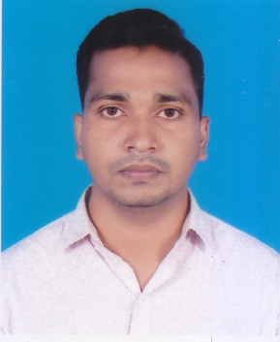**CURRICULUM VITAE**

**OF**

**MASOM MIA**

**Mobile : 01837-624281**

**Email: masommia3983@gmail.com**

* **CAREER OBJECTIVE:**

To Pursue a challenging career in a dynamic, financial organization where have the opportunity to utilize my academic/earning to ensure the development of organizational goal as well as personal career.

**EDUCATIONAL QUALIFICATION :**

**Bachelor Of [Social Science](https://www.sh.se/p3/ext/content.nsf/aget?openagent&key=subjects_1353397741736) (BSS) Hon’s**

University : National University

Name of Institution : Narsingdi Govt. College

Group : Sociology

Result : CGPA--3.01

Year of Passing : 2017

**H.S.C. (Higher Secondary Certificate)**

Board : Dhaka

Name of Institution : Baroicha College.

Group : Humanities

Result : GPA-4.10

Year of Passing : 2013

**S.S.C. (Secondary School Certificate)**

Board : Dhaka

Name of Institution : Dhukundi High School.

Group : Humanities

Result : GPA-4.06

Year of Passing : 2011

* **LANGUAGE PROFICENCY:**

|  |  |  |  |
| --- | --- | --- | --- |
| **Language** | **Reading** | **Writing** | **Speaking** |
| Bengali | | Best | Best | Best |
| English | | Best | Better | Good |

* **HOBBY:**

Playing, cricket, Traveling, Reading, Novel Books, IT Nears & Listening music.

* **SPECIAL QUALIFICATION :**
* Have basic working knowledge of Microsoft Office Package
* M.S. Word, M.S. Excel, M.S. Power Point
* Internet Browsing
* **PERSONAL INFORMATION:**

Name **: Masom** M**ia**

Father's Name : Md. Manik Mia

Mother's Name : Rahima Begum

Date of Birth : 20/12/1994

Sex : Male

Religion : Islam

Nationality : Bangladeshi (by birth)

Marital Status : Unmarried

Height : 5 ©. 6 © ©

Blood Group : O-

* **PRESENT ADDRESS :**

Village : Dhukundi

Post Office : Uzilabo

Police Station : Belabo

District : Narsingdi

* **PERMANENT ADDRESS :**

Village : Dhukundi

Post Office : Uzilabo

Police Station : Belabo

District : Narsingdi

* **DECLARATION:**

I declare that all the information included here are true to my knowledge. If required and where applicable, this document can be supported by appropriate authentic certificates.

**Date: Masom** M**ia**